Day 23 — DStreams Basics

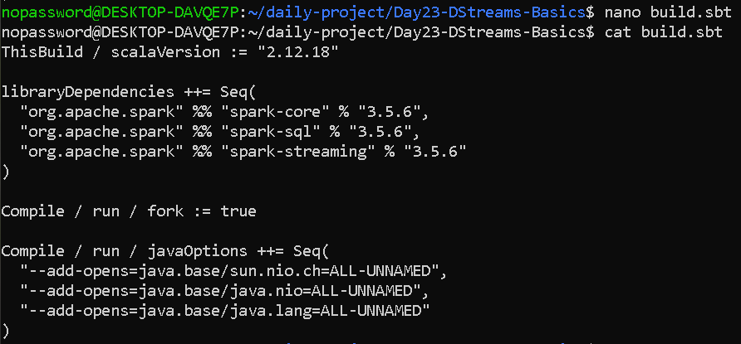

Create the Scala program
nano DStreamsBasics.scala

import org.apache.spark.SparkConf
import org.apache.spark.streaming.{Seconds, StreamingContext}

object DStreamsBasics {

def main(args: Array[String]): Unit = {

// ------------------------------------------------
// Spark Configuration
// ------------------------------------------------

val conf = new SparkConf()
.setAppName("DStreams Log Error Counter")
.setMaster("local[2]")

// ------------------------------------------------
// Create Streaming Context
// ------------------------------------------------

val streamingContext =
new StreamingContext(conf, Seconds(5))

streamingContext.sparkContext.setLogLevel("ERROR")

println("\n======================================")
println(" DAY 23 - DSTREAMS BASICS")
println("======================================")

println("\nBatch Interval: 5 seconds")
println("Waiting for log messages...\n")

// ------------------------------------------------
// 1. Read data from socket
// ------------------------------------------------

val lines =
streamingContext.socketTextStream(
"localhost",
9999
)

// ------------------------------------------------
// 2. flatMap()
// ------------------------------------------------

val words = lines.flatMap(
line => line.split("\\s+")
)

// ------------------------------------------------
// 3. filter()
// ------------------------------------------------

val errorWords = words.filter(
word => word.toUpperCase == "ERROR"
)

// ------------------------------------------------
// 4. map()
// ------------------------------------------------

val errorCount = errorWords.map(
word => ("ERROR", 1)
)

// ------------------------------------------------
// 5. Count ERROR messages
// ------------------------------------------------

val totalErrors = errorCount.reduceByKey(
(a, b) => a + b
)

// ------------------------------------------------
// 6. Display result every batch
// ------------------------------------------------

totalErrors.foreachRDD { rdd =>

if (!rdd.isEmpty()) {

println("\n--------------------------------------")
println("New 5-second batch")
println("--------------------------------------")

rdd.collect().foreach {
case (word, count) =>
println(word + " messages: " + count)
}
}
}

// ------------------------------------------------
// Start Streaming
// ------------------------------------------------

streamingContext.start()

// Keep application running
streamingContext.awaitTermination()
}
}

OUTPUT—
The right terminal shows 3 errors because there are sent 3 ERROR lines sent .
